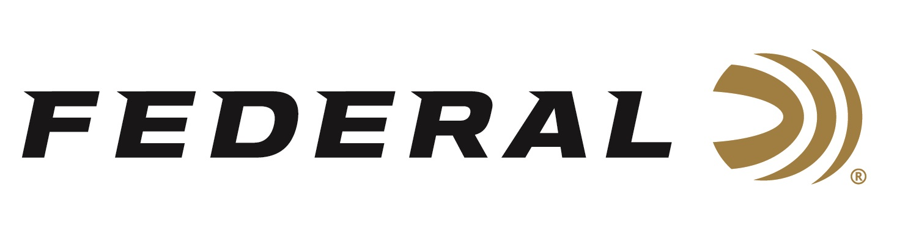

FOR IMMEDIATE RELEASE

**Federal Ammunition Sponsored Shooters Earn ATA All-American Status**

**ANOKA, Minnesota –** **October 2, 2025 –** Federal Ammunition congratulates its passionate list of sponsored trap shooters on an outstanding year of knocking down targets. Nine shooters earned All-American recognitions in their respective categories while one shooter earned the honor of being named Captain. ATA All-American Team selections are made based on the All-American Awards Point System for the entire year and other criteria outlined by the ATA.

Leading the team is ATA Hall of Famer Deborah Ohye-Neilsen, who earned her 38th straight All-American status in 2025. She was the second highest point earner in the Lady II category. “Deborah is an absolute gem and a top ambassador for the sport,” says Mike Hampton Sr., Federal Ammunition’s Shotgun Sports Team Manager. “She has a 42-year history of competing at the Grand American and holds a record of twenty-five Captaincy designations in ATA history. It is a privilege to work with a true legend of the sport,” says Hampton.

Others on Team Federal that earned All-American honors include Patrick Hopson in Open second team and Lauren Dunn in Lady I second team. Grayson Stuart earned a spot on the Junior Gold second team and in the Sub-Veteran first team, Federal landed three shooters on the All-American list that includes Tim Reed, Scott Gens, and Eric Munson. Michael Gooch earned placement on the Sub-Veteran second team and lastly, Frank Payne is an All-American in the Senior Vet first team category. Federal Ammunition extends a sincere congratulations to these shooters earning their way onto their respective All-American teams.

Of the ten Amateur Trapshooting Association (ATA) categories, one Federal shooter earned the prestigious distinction of being named Captain. Based on his performance and total points earned for the year, Ziggy Tkaszenko of Missouri was named Chairshooter team Captain.

Federal Ammunition products, including the all-new All-American, are available at dealers nationwide and online. This competition-level trap load features a Podium wad that is customized for straight-wall hulls. The design’s exclusive compression zone cushions the payload at ignition for better patterns and softer shooting. Federal’s reliable primers, high-antimony lead shot, and select propellant round out a performance shell that crushes the toughest targets. For more information on All-American and all Federal products, visit [www.federalpremium.com](http://www.federalpremium.com).

Federal Ammunition products are available at dealers nationwide and online. For more information on all Federal products, visit [www.federalpremium.com](http://www.federalpremium.com).

**Press Release Contact:** JJ Reich

Senior Manager – Press Relations

E-mail: media@tkghunt.com

**About Federal Ammunition**

Federal, headquartered in Anoka, MN, is an ammunition brand of The Kinetic Group, owned by CSG, a globally diversified industrial group based in Prague (Czech Republic). From humble beginnings nestled among the lakes and woods of Minnesota, Federal Ammunition has evolved into one of the world's largest producers of sporting ammunition. In 1922, founding President Charles L. Horn paved the way for our success. Today, Federal carries on Horn's vision for quality products and services with the next generation of outdoorsmen and women. We maintain our position as experts in the science of ammunition production. Every day, Federal manufactures products to enhance our customers' shooting experience while partnering with the conservation organizations that protect and support our outdoor heritage. Federal offers thousands of options in our Federal Premium® and standard Federal® lines, which is what makes it the most complete ammunition company in the business and helps it provide customers with a choice no matter what the pursuit.